Asit Kumar

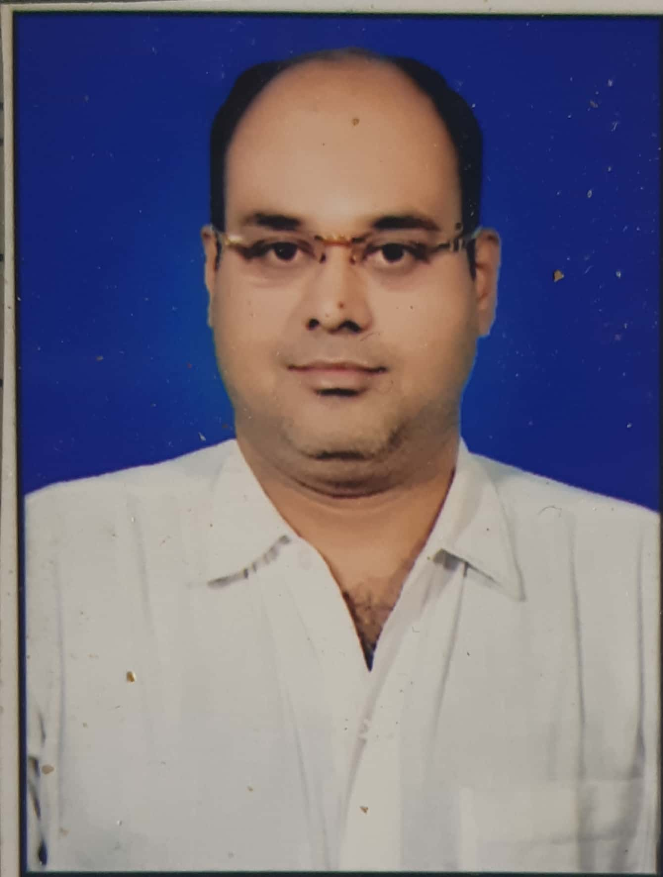

Assistant professor of zoology,

Govt.R V R S Girls college, Kawardha C G

asitraipur@gmail.com

[Conservation Biology](https://scholar.google.com/citations?view_op=search_authors&hl=en&mauthors=label:conservation_biology)[Biodiversity.](https://scholar.google.com/citations?view_op=search_authors&hl=en&mauthors=label:biodiversity)

Top of Form

Bottom of Form

Top of Form

|  |  |  |  |
| --- | --- | --- | --- |
|  | [TITLE](https://scholar.google.com/citations?hl=en&user=pQriNrEAAAAJ&view_op=list_works&sortby=title) | CITED BY | [YEAR](https://scholar.google.com/citations?hl=en&user=pQriNrEAAAAJ&view_op=list_works&sortby=pubdate) |
|  | [Diversity and seasonal variation of soil mycoflora of Bilaspur district of Chhattisgarh state](https://scholar.google.com/citations?view_op=view_citation&hl=en&user=pQriNrEAAAAJ&citation_for_view=pQriNrEAAAAJ:u-x6o8ySG0sC)  R Mishra, D Shrivastava, A Kumar  Indian Journal of Scientific Research 13 (2), 184-187 | [2](https://scholar.google.com/scholar?oi=bibs&hl=en&cites=16208320636359041447) | 2017 |
|  | [Physico-chemical analysis of drinking water in Lormi tehsil of Chhattisgarh state.](https://scholar.google.com/citations?view_op=view_citation&hl=en&user=pQriNrEAAAAJ&citation_for_view=pQriNrEAAAAJ:zYLM7Y9cAGgC)  R Mishra, A Kumar, S Tripathi  Trends in Biosciences 11 (6), 816-817 |  | 2018 |
|  | [Heavy metal toliarent soil microflora: A natural resource of Bioremediation](https://scholar.google.com/citations?view_op=view_citation&hl=en&user=pQriNrEAAAAJ&citation_for_view=pQriNrEAAAAJ:9yKSN-GCB0IC)  DKSBPT Richa Mishra, Asit Kumar  Progressive Research - An International Journal 12 ((Special IV)), 2464 - 2466 |  | 2017 |
|  | [Evaluation of Antagonistic behavior of soil Mycoflora of Bilaspur District](https://scholar.google.com/citations?view_op=view_citation&hl=en&user=pQriNrEAAAAJ&citation_for_view=pQriNrEAAAAJ:d1gkVwhDpl0C)  AKDKS Richa Mishra  FLORA AND FAUNA 23 (Special Issue), 127-130 |  | 2017 |

<https://scholar.google.com/citations?user=pQriNrEAAAAJ&hl=en>Bottom of Form